Tracking faces in TV Shows

In order to automatically identify speakers in a video, it is necessary to recognize and track human faces. There are a number of solutions to

I) Microsoft Cognitive Solutions – Video API

Microsoft propose the face tracking mode of its Video API for free. Video files smaller than 100 MB can be uploaded via HTTP request, analysed, and the results are sent back in a JSON file.
The API was tested using a modification of the sample project provided by Microsoft. This software allows us to easily check the performances of the API by outlining the tracked faces in the video and saving the JSON file onto the computer.
It takes about 10 minutes to analyse a 3-minute video. Most faces are tracked accurately, but frontal faces give the best results. Profile faces, very small faces (less than 24x24), or very large face angles may not be recognized. Up to 64 different faces can be tracked.
The major problem with the Microsoft API is that it is impossible to use it to analyse 1-hour-long per the 100 MB limit. In order to analyse longer file, it is necessary to find another solutions.

II) OpenCV Face detection

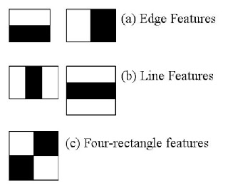
The open-source computer vision library OpenCV comes with a built-in face recognition module based on Haar Feature-based cascade classifier.

Figure 1 : Haar Feature

The idea of a cascade classifier is that you can divide the picture into different windows and quickly discard those which are unlikely to be faces. In order to do that, features are grouped into different stages and applied one by one. Windows that failed the 1st stage won’t be analysed in the 2nd.
OpenCV comes with a lot of pre-trained classifiers in the form of XML files. It is possible to read the video and apply the classifiers to each frame in order to track faces in the video.
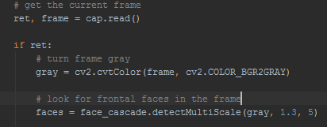

However, if many different persons appear in the video, their faces will not be tracked separately. Moreover, the algorithm has trouble tracking profile faces, even when the set of classifier specific to profile faces is used. While it is not a huge problem for TV show as the speaker often faces the camera, a slight tilt of the head can be enough to cause a failure of the algorithm.
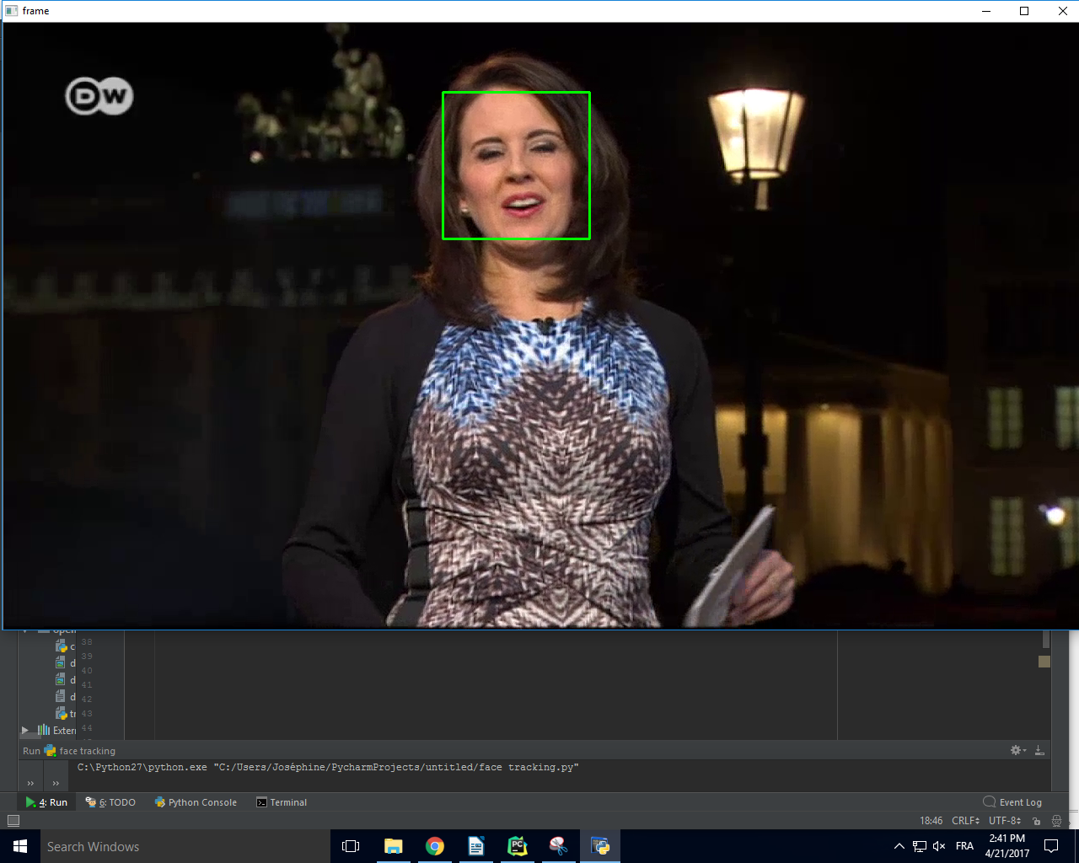
It is therefore necessary to solve this problem and add a face recognition module to the program so we can use it to answer the question “Who speaks when ?”

Exemple 1 : the face of the host is tracked properly


Exemple 2 : a downward-turned face can’t be tracked

Sources :

http://docs.opencv.org/3.2.0/d7/d8b/tutorial_py_face_detection.html

https://docs.microsoft.com/en-us/azure/cognitive-services/Video/How-To/HowtoCallVideoAPIs

